

LEFT: TmpC = 23

RIGHT:TmpC = 30

This Phenomenon is present in both Kenneth’s model version and my model version.

What type of behaviour SHOULD we expect (search through literature)

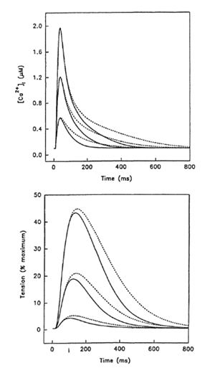

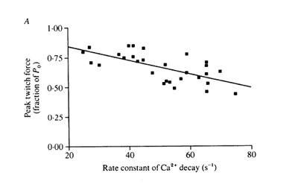

Steeper rates of [Ca2+]i decay result in a LOWER peak twitch force (skeletal)

cardiac cells- simulation

For each of your isometric contractions (at different SLs), your full model has predicted Ca transients.

You have, thus far, taken the biggest Ca transient and applied it to workloops to predict the workloop end-systolic r/s.

1. I think you should do the same with all the other isometric Ca transients to produce a ‘family’ of workloop end-systolic r/s, each driven by a different Ca transient.

Do the afterloads for the workloops coincide with the peak force for each of the isometric contractions?

1. I think the next simulation would be to take the each isometric Ca transient and apply it to the corresponding force-equivalent workloop  and see what that predicts for the workloop end-systolic curve.